**ЛАБОРАТОРНАЯ РАБОТА №11**

Создадим проект команда: **create-react-app my-todolist-app**

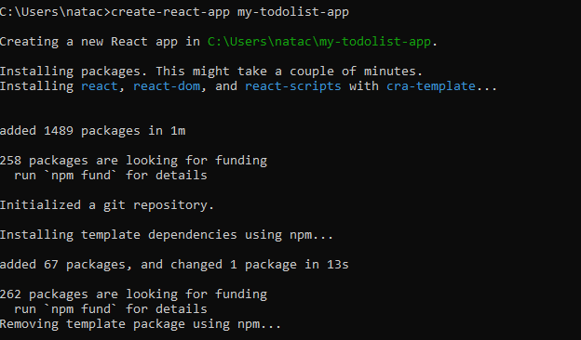

Перейдем в директорию : **cd my-todolist-app**

Перепишем скрипт на React:

**App.js**

import React, { useState } from 'react';

import './style.css';

const initialTodoListData = [

{ task: "Сделать дело", createdAt: "05/02/2024" },

{ task: "Погладить кошку", createdAt: "06/02/2024" },

{ task: "Посадить картошку", createdAt: "06/02/2024" },

{ task: "Прочитать книгу", createdAt: "07/02/2024" },

{ task: "Сходить в магазин", createdAt: "05/03/2024" },

];

const TodoList = () => {

const [todoListData, setTodoListData] = useState(initialTodoListData);

const [taskText, setTaskText] = useState('');

const createListItem = () => {

if (taskText.trim() !== '') {

const currentDate = new Date().toLocaleDateString('en-GB');

const newTask = { task: taskText, createdAt: currentDate };

setTodoListData([...todoListData, newTask]);

setTaskText('');

}

};

const removeListItem = index => {

const newList = [...todoListData];

newList.splice(index, 1);

setTodoListData(newList);

};

const clearList = () => {

setTodoListData([]);

};

return (

<div className="mainPart">

<div className="menu">

<input

className="inputText"

type="text"

placeholder="Новый элемент списка"

value={taskText}

onChange={e => setTaskText(e.target.value)}

/>

<button className="addButton" onClick={createListItem}>Добавить</button>

<button className="clearButton" onClick={clearList}>Очистить всё</button>

</div>

<div className="uList">

{todoListData.length === 0 && (

<div className="hiddenText">Не найдено ни одного дела</div>

)}

<ul className="list-container">

{todoListData.map((item, index) => (

<li key={index} onClick={() => removeListItem(index)}>

<div>

{item.task}

<sub>от {item.createdAt}</sub>

</div>

<button>✖️</button>

</li>

))}

</ul>

</div>

</div>

);

};

const App = () => {

return (

<div className="app-container">

<header>

<h1>Список дел</h1>

</header>

<TodoList />

<footer>

<hr />

<div className="footer-text">Copyright ©</div>

</footer>

</div>

);

};

export default App;

**style.css**

body {

background-color: #122221;

font-family: 'Gill Sans', 'Gill Sans MT', Calibri, 'Trebuchet MS', sans-serif;

}

.app-container {

display: grid;

grid-template-rows: auto 1fr auto;

height: 100vh;

}

header {

color: #EAD2CE;

font-size: 36pt;

text-align: center;

}

mainPart {

display: flex;

flex-direction: column;

align-items: center;

justify-content: flex-start;

height: 100%;

margin: auto;

}

.menu {

display: flex;

align-items: center;

width: 60%;

margin-top: 20px;

}

.inputText {

background-color: #EAD2CE;

color: #125446;

font-size: 20pt;

width: 60%;

}

.addButton,

.clearButton {

cursor: pointer;

background-color: #125446;

color: #EAD2CE;

font-size: 20pt;

width: 20%;

}

.addButton:hover,

.clearButton:hover {

background-color: #3B877A;

color: #122221;

}

.hiddenText {

color: #EAD2CE;

font-size: 27pt;

}

.uList {

background-color: #3B877A;

color: #122221;

width: 60%;

height: 60%;

overflow-y: auto;

padding: 10px;

}

.list-container {

list-style-type: none;

padding: 0;

}

.list-container li {

display: flex;

justify-content: space-between;

align-items: center;

padding: 10px 0;

border-bottom: 1px solid #125446;

}

.list-container li:last-child {

border-bottom: none;

}

.list-container li:hover {

background: #125446;

color: #EAD2CE;

}

.list-container li button {

background-color: #125446;

color: #EAD2CE;

font-size: 30pt;

width: 60px;

height: 60px;

border: none;

}

.list-container li button:hover {

background-color: #DB8C7B;

}

**Запускаем Todo-List:**

